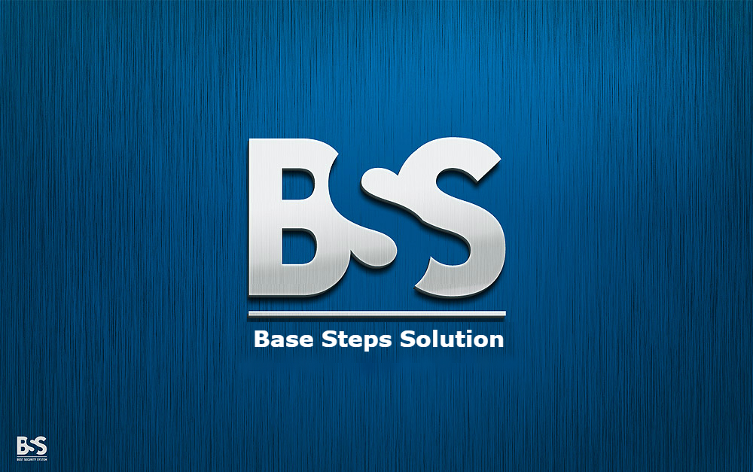

Configuration Managemet Plan

Văn Lang Admissions

# Revision Table

|  |  |  |  |
| --- | --- | --- | --- |
| Author | Date | Reason for changes | Version |
| Khoi Nguyen | 13/10/2016 | Initial the document | 1.0 |
| Khoi Nguyen | 23/10/2016 | Update Process  Update Configuration Identification | 1.1 |
| Khoi Nguyen | 1/11/2016 | Update Process upload documents | 1.2 |

Table of Contents

Revision Table 1

1. INTRODUCTION 3

1.1. Purpose 3

1.2. Definitions, acronyms and abbreviations 3

1.3. Audience 4

2. CONFIGURATION MANAGEMENT 4

2.1. Organization 4

2.2. Training 6

3. CONFIGURATION MANAGEMENT ACTIVITIES 6

3.1. Configuration Items 6

3.2. Configuration Identification 6

3.2.1. Document name 6

3.2.2. Document content 8

3.2.3. Tool for store and access to the repository 11

3.2.4. Tool for testing 12

3.2.6. Tools for product development 12

3.2.7. Organize folders to store document 12

3.2.8. Process 15

3.3. Artifact Life Cycle 17

3.4. Manage version 18

3.4.1. Update Status Change of the Document (Revision Table) 18

3.4.2. Set Version for Document 18

APPENDIX A: REFERENCES 18

# INTRODUCTION

## Purpose

The overall objective of a Configuration Management (CM) Plan is to document and inform project stakeholders about CM with the project, what CM tools will be used, and how they will be applied to the project.CM Plan defines the project’s structure and methods for:

* Identifying, defining, and baseline configuration items (CI);
* Create the repository where all revisions of all files necessary to create any product version can be found.Controlling modifications and releases of CIs;
* Reporting and recording status of CIs and any requested modifications;
* Ensuring completeness, consistency, and correctness of CIs;
* Controlling storage, handling, and delivery of the CIs;
* Complying with naming convention and standard.

## Definitions, acronyms and abbreviations

This following table describes key terms and important acronyms in this project:

|  |  |  |
| --- | --- | --- |
| No. | Term | Definition |
| 1 | BSS | Base Steps Solution Team who develop this project |
| 2 | CM | Configuration Management |
| 3 | CI | Configuration Item |
| 4 | PM | Project Manager |

## Audience

The intended audience of the CM Plan is the Project manager , Phase leader, Configuration manager, Project team, Project sponsor and anyone that support is needed to carry out communication plans.

|  |  |
| --- | --- |
| Intended Audience | Description |
| Project Manager & Configuration Manager | Whole the document for managing configurations of the project |
| Phase leader | Managing configurations of each phase. |
| Project Team | Work base on CM Plan |
| Project sponsor and anyone that support | Allow to read |

# CONFIGURATION MANAGEMENT

## Organization

Responsibility of configuration management:

* Project Manager and Configuration Manager is major responsibility for manage the configuration of the project.
* All team members have respnsibility to follow the flow in this document in order to preserve the integrity, traceability and modifiability of all artifacts in the software configuration. Maintenance of this configuration itself is also a responsibility of all team members of the BSS team.

***General guideline:***

* When creating documents or making changes, follow these general guideline to prevent collisions
* If you are not sure about the name of a new file or the directory where it should be saved, ask the configuration manager in the team. Most artifacts should follow a naming convention. If you create a new file, check in this document if there is a convention that applies.
* All documents should use the same visual style and basic structure. Use the template available and avoid formatting paragraphs – use the styles available in the template.

## Training

* Use Github for integrating source code.

# CONFIGURATION MANAGEMENT ACTIVITIES

## Configuration Items

|  |  |  |
| --- | --- | --- |
| No. | Category | Item List |
| 1 | Document | Document name |
| Document content (font, size, table, header, footer, bullets, color, ...) |
| 2 | Process | Process to add or modify Capstone Project’s documents on Github |
| Process submit document to Github repository |
| 3 | Tool | Tool for access to the repository |
| Tool for testing |
| Tools for editing documents |
| Tools for product development |
| 4 | Organization | Organize folders to store document |

## Configuration Identification

### Document name

Document’s name convention:

***BSS_< Name of document > _<Version>***

Example: Name of configuration management plan documents: ***BSS_ConfigurationManagementPlan_v1.0.doc***

Meeting minute and Effort log’s name convention :

* *Meeting minute:*
* Meeting with customer: BSS_MeetingMinute_Customer#_<dd.mm.yy>
* Meeting with mentor: BSS_Meeting Minute_Mentor#_<dd.mm.yy>
* Meeting with team: BSS_Meeting Minute_Team#_<dd.mm.yy>
* *Time log:*
* BSS_EffortLog_<First name><Last Name>_<Week#>

Note : Because in team include 2 members have the same firstname and lastname , so : _<First name><Last Name>_

- Nguyen Thai Hien : HienNguyen

- Nguyen Xuan Thai Hien : HienXuanNguyen

### Document content

#### Word Document

|  |  |  |
| --- | --- | --- |
| No. | Item | Convention |
| 1 | Font | Normal: Times New Roman |
| 2 | Style | * Title: * Font : Times New Roman * Font size: 30 * Font style: Normal * Font color: Light Blue (Custom: Color model: RGB, Red: 0, Green: 160, Blue: 184) * Heading level 1: * Font : Times New Roman * Font size: 18 * Font style: Normal – Upper Case * Font color: Light Blue (Custom: Color model: RGB, Red: 0, Green: 160, Blue: 184) * Heading level 2: * Font : Times New Roman * Font size: 16 * Font style: Normal – Upper Case * Font color: : Light Blue (Custom: Color model: RGB, Red: 0, Green: 160, Blue: 184) * Heading level 3: * Font : Times New Roman * Font size: 14 * Font style: Normal * Font color: Light Blue (Custom: Color model: RGB, Red: 0, Green: 160, Blue: 184) * Heading 4: * Font : Times New Roman * Font size: 14 * Font style: Normal - Italic * Font color: Light Blue (Custom: Color model: RGB, Red: 0, Green: 160, Blue: 184) * Normal Style: * Font size: 14 * Font: Times New Roman * Font style: Normal * Font color: Black , Text 1 , Lighter 35% (Custom: Color model: RGB, Red: 89, Green: 89, Blue: 89) |
| 3 | Table | * Column header: * Fill color: Light Blue (Custom: Color model: RGB, Red: 0, Green: 160, Blue: 184) * Font color: White * Font style: Bold * Font: Times New Roman * Font size: 14 * Position: Center alignment * Cell: * Fill color: No color * Font color: Black , Text 1 , Lighter 35% (Custom: Color model: RGB, Red: 89, Green: 89, Blue: 89) * Font size: 14 * Font style: Normal * Font: Times New Roman * Line Color: Light Blue (Custom: Color model: RGB, Red: 0, Green: 160, Blue: 184) |
| 4 | Header | As header of this document |
| 5 | Footer | As footer of this document |
| 6 | Bullets | * Bullet level 1   + Bullet level 2     - Bullet level 3 |
| 7 | Template | Adopt the word document in Google Drive |

Table 2: Word Document Convention

#### Excel Document

|  |  |  |
| --- | --- | --- |
| No. | Item | Convention |
| 1 | Font | * Font : Times New Roman * Font size: 14 * Font style: Normal * Font color: Black |
| 2 | Column Header | * Font : Times New Roman * Fill color (Background color): Blue , Accent 1 (Custom: Color model: RGB, Red: 91, Green: 155, Blue: 213) * Size: 14 * Font style: Bold * Font color: White * Position: Center text |
| 3 | Cell | * Fill color (Background color): No color * Size: 14 * Font color: Black * Position: Normal |
| 4 | Template | * Adopt the excel document in Google Drive |

Table 3: Excel Document Convention

### Tool for store and access to the repository

|  |  |  |
| --- | --- | --- |
| Item | Description | |
| Name | | GitHub |
| URL | | https://github.com/HienNguyen126/BaseStepsSolution-Capston/tree/Documents |
| Username | | Personal account |
| Password | | Personal account |

|  |  |
| --- | --- |
| Item | Description |
| Name | GitHub |
| URL | https://github.com/HienNguyen126/BaseStepsSolution-Capston/tree/Source-code |
| Username | Personal account |
| Password | Personal account |

|  |  |
| --- | --- |
|  |  |

### Tool for testing

|  |  |
| --- | --- |
| Item | Description |
| Name |  |
| URL |  |
| Username |  |
| Password |  |

1. Tools for editing documents

|  |  |
| --- | --- |
| Name | Description |
| Microsoft Office 2010 or later | Microsoft Word Microsoft Excel Microsoft Powerpoint  Microsoft Visio  Microsoft Project |

Table 4: Tools for editing document

### Tools for product development

|  |  |
| --- | --- |
| Name | Description |
| ATOM |  |

Table 5: Tools for product development

### Organize folders to store document

All the documents of this project are stored Github[Capstone Project]. The following table describes organization and structure folders:

|  |  |  |
| --- | --- | --- |
| Root folder | Subfolder | Description |
| 1. Deliverables | 1.1 Kick-Off | Contains Kick-Off documents |
| 1.2 Planning | Contains Planning documents |
| 1.3 Requirement | Contains document of requirement phase |
| 1.4 Architecture & Design | Contains document of Architecture & Design phase |
| 1.5 Implementation | Contains document of implementation phase |
| 1.6 Testing | Contains document of testing phase |
| 1.7 Project Management | Contains document of project management |
| 1.8 Monitor & Control | Contains documents for monitor & control project |
|  | 1.9 Processes | Contains all process of project |
| 2. Training | 2.1 Programing Languages | Contains trainning document about tools , programming language |
| 2.2 Tools |
| 3. Meeting Minutes | 3.1 Meeting with Customer | Contains record of meeting with Customer |
| 3.2 Meeting with Mentor | Contains record of meeting with Mentor |
| 3.3 Meeting with Team | Contains record of meeting with Team |
| 4. Presentation | 4.1 Powerpoint | Contains presentation files of the project |
| 4.2 Deliverables |
| 4.3 Team Evaluation |
| 5. Document Template | 5.1 Kick-Off Templates | Contains Kick-Off document templates |
| 5.2 Planning Templates | Contains planning document templates |
| 5.3 Requirement Templates | Contains document templates of Requirement. |
| 5.4 Architecture & Design Templates | Contains document templates of Architecture & Design |
| 5.5 Implementation Templates | Contains document templates of Implementation |
| 5.6 Testing Templates | Contains document templates of Testing. |
| 5.7 Project Management Templates | Contains document templates of Project Management. |
| 5.8 EffortLog Templates | EffortLog Template |
| 6. Reference |  | Some references to additional knowledge |
| 7. Individual Submit | 7.1 Hai Tran | Where tasks submit by each member of team |
| 7.2 Hien Nguyen |
| 7.3 Khoi Nguyen |
| 7.4 Tai Nguyen |
| 7.5 Minh Doan |
| 7.6 Xuan Thai Hien |
| 8. Effort Log | 8.1 Hai Tran | Where Effort Log submit by each member of team |
| 8.2 Hien Nguyen |
| 8.3 Khoi Nguyen |
| 8.4 Tai Nguyen |
| 8.5 Minh Doan |
| 8.6 Xuan Thai Hien |

Table 6: Folder Structure in Github

### 3.2.8. Process

3.2.8.1 Process to add or modify Capstone Project’s documents on Google Drive



3.2.8.2 Process submit document to Github repository

C:\Users\Khoi Nguyen\Downloads\implementation process1.png

## Artifact Life Cycle

|  |  |  |  |
| --- | --- | --- | --- |
| No. | Configuration Item | Start | End |
| 1 | Document name | Applied throughout entire process | |
| 2 | Document content (font, size, table, header, footer, bullets, margins) | Applied throughout entire process | |
| 3 | Tool for store and access to the repository | Applied throughout entire process | |
| 4 | Tool for testing | Applied throughout entire process | |
| 5 | Tools for editing documents | Applied throughout entire process | |
| 6 | Tools for product development | Implement phase | Test phase |
| 7 | Organize folders to store document | Applied throughout entire process | |

Table 7: Artifact Life Cycle

## Manage version

### Update Status Change of the Document (Revision Table)

|  |  |  |  |
| --- | --- | --- | --- |
| Author | Date | Describe about changes | Version |
| First Name – Last Name | dd/mm/yyyy | The content which has been changed | Va.b |

Table 8: Update version to revision table

* When create or update document, Author must update information of revision history table
* Date, the version number on the cover page (page 1) must be identical to the record date and the final version of the document history table.

### Set Version for Document

Version of the product includes versions of the System, Subsystem and Components of the product. Depend on the type of project that the System, Subsystem and Component can carry the same or different versions.

* Number of document version including the 3 – digit format: va.b The first version of the document (after review and approval the first time) brought the number v1.0 (Version 1.0)
* If the document was upgraded level will have b version number increase, respectively: va.1, va.2, va.3, va.4 ... (Version a.1, Version a.2, Version a.3 ... Version a.9 -> Version a + 1.0 )

# APPENDIX A: REFERENCES

eplc_configuration_management_template (<http://www.hhs.gov/ocio/eplc/EPLC%20Archive%20Documents/08%20-%20Configuration%20Management%20Plan/eplc_configuration_management_template.doc>)